Project Title
unLeish: A new age therapeutic bacteria to detect the presence of Leishmania and fight against it
-By team IISER_Kolkata

Introduction
Our goal is to address a highly neglected but deadly disease named visceral leishmaniasis which claims thousands of lives every year, in many countries around the globe, with a hotspot in the Indian subcontinent. It mainly infects the visceral organs of the body viz. liver and spleen which are the primary hubs of macrophage localisation. To tackle it, we are constructing a genetic circuit which can specifically sense the presence of Leishmania donovani inside a macrophage and trigger a biochemical pathway to efficiently kill it inside the macrophage itself. The engineered bacteria (GMO), unLeish will be injected intravenously into the hepatic portal vein for liver infections and in the splenic artery for splenic infections. Moreover, unLeish will have certain characteristics that will enable it to proliferate selectively only in the Leishmania-infected macrophages and not in uninfected macrophages or the bloodstream. As working with Leishmania donovani is very hazardous, hence we will be working with Leishmania major, a much milder species from the same genus causing cutaneous leishmaniasis, (a self-healing and easily curable infectious disease) which has a similar life cycle and infection strategies.

Our strategy
Pathogenic bacteria have a natural ability to survive and grow inside the host. They have different genetic information encoded in their genome, some of the genetic codes are responsible for their surviving inside the host, and some others produce different toxins which are responsible for causing diseases in the host. If we knock out the genes which are responsible for producing toxins, the knockout bacteria can survive and grow inside the host without causing any diseases. The bacterial chassis that we project to use as a therapeutic agent is E. coli O55:H7 with the gene for Shigella toxin and other adhesive factors knocked out to avoid any toxicity in the body. This would ensure that the bacteria are not pathogenic (causes no diseases or side effects) but will still retain its virulence to survive inside the macrophage. But as the strain requires to maintain biosafety levels, thus the proof of model for the engineered genetically modified organism (GMO) will be done using a harmless bacterial chassis E. coli DH5α.
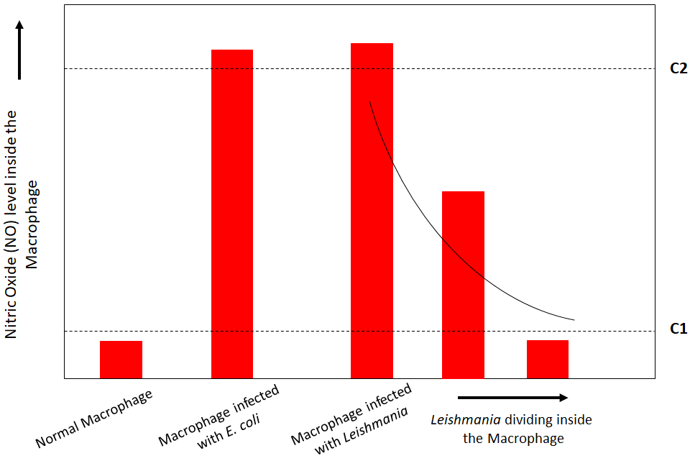
Leishmania stays inside the macrophages of the host, at the early stage of Leishmania infection, Nitric Oxide (NO) level inside the macrophage increases significantly (same for all kind of pathogenic infection) but as the Leishmania starts dividing inside the macrophage, it gradually reduces the level of NO inside the macrophage (Fig 1.), and ultimately the NO level becomes normal (same NO level as of an uninfected macrophage). We are going to introduce some genetic circuit inside the knockout bacteria which can sense the presence of Leishmania inside a macrophage by sensing this gradually decreasing NO level and act accordingly.
Fig 1. NO level inside macrophage under different circumstances
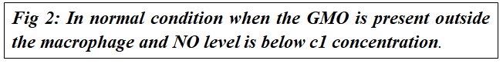
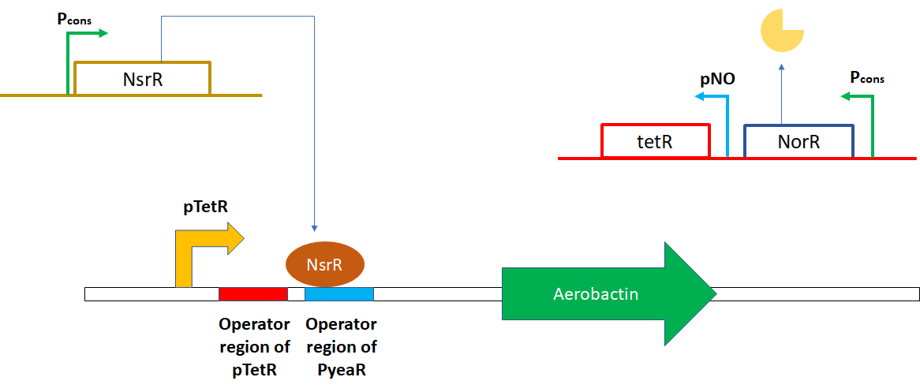
Our genetic circuit has three main components; the first one is a siderophore (iron chelator) producing gene, which is under control of one promoter and two operator sites for the binding of two different inhibitors. The other two components produce two different inhibitors under two different circumstances. When the NO level is very low (this is the condition when bacteria is outside the macrophage) only one inhibitor (inhibitor1 or NsrR) will produce which will bind to one particular operator site (operator1 or operator region of PyeaR) and inhibit siderophore production (Fig 2.). When the NO level is very high (this is the condition when our genetically modified bacteria will be engulphed by an uninfected macrophage) inside the macrophage, another inhibitor (inhibitor2 or TetR) will produce and bind to another operator site (operator2 or operator region of pTetR) and inhibit siderophore production. When the bacteria will engulphed by an infected macrophage, only then the siderophore will produce, because inhibitor1 only inhibits the production of siderophore at a very low NO concentration and inhibitor2 starts inhibiting at very high NO concentration but a macrophage where Leishmania is dividing, the NO concentration is in between very high and very low (because Leishmania gradually reduces NO concentration) and in this condition (when the NO level is in between c1 and c2 from Fig 1.) none of the inhibitors will inhibit siderophore production (Fig 4.).

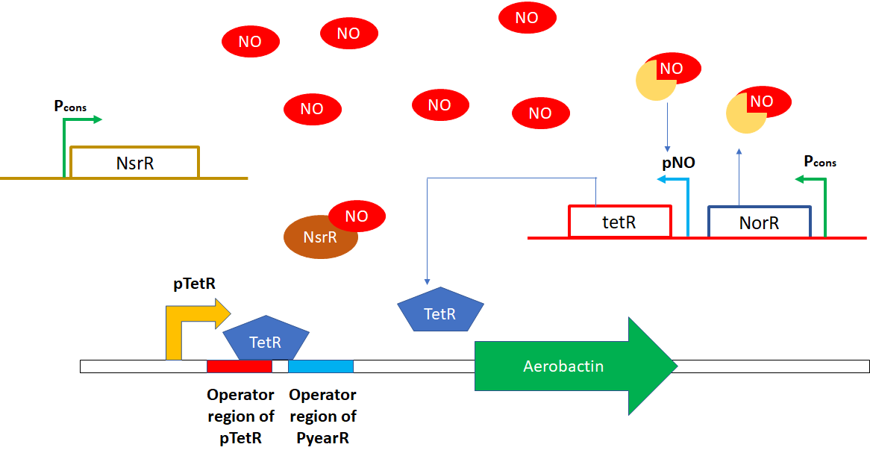
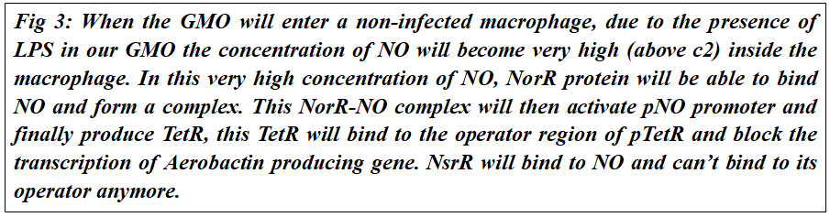

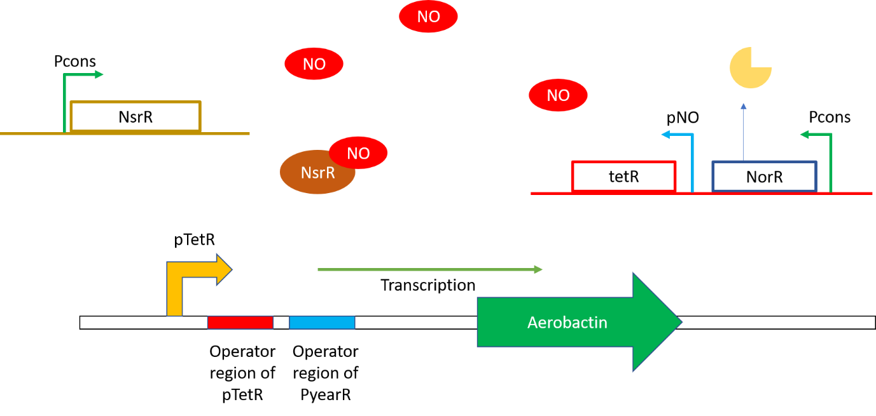
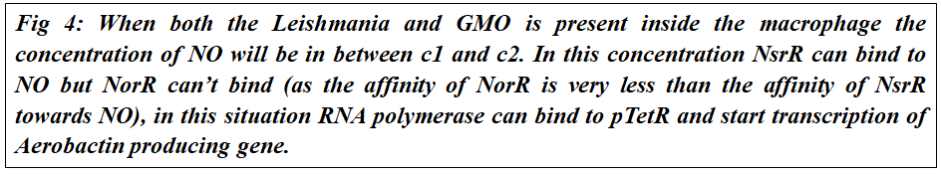

After entering the host cell our GMO will be engulphed by the macrophages, inside a macrophage, the bacterium will sense whether the macrophage is infected by Leishmania or not, by sensing its microenvironment (i.e. nitric oxide level) inside the phagolysosome and in response to this, it will conditionally start the expression of iron chelating agents (Aerobactin). Iron is required for both Bacteria and Leishmania, by using aerobactin bacteria will use up most of the available iron for Leishmania, due to iron deprivation the growth of Leishmania will be inhibited.
The growth rate of bacteria is much faster than that of Leishmania, at a certain population density of bacteria, the bacteria will start the expression of pyruvate oxygenase, an enzyme which produces a reactive oxygen species, H₂O_{2,} using a quorum sensor-based induction circuit. This ROS burst will effectively kill both the remaining Leishmania parasite and our engineered bacteria inside the phagolysosome.

Significance of our Project
World Health Organization (WHO) data indicate that an estimated up to 1 million new cases and 20k-30k deaths by leishmaniasis occur annually in the world. The costs for curing leishmaniasis range from 14k INR to 90k INR, which is often unaffordable for the poor. The treatment itself has a high risk of causing side effects, some of which are life-threatening. All nation-wide programs to eradicate the disease have failed, possibly due to the cyclical epidemiological pattern caused by drug resistance of the parasite. The pathogens causing Leishmaniasis can gain resistance against modern drugs over time, which we are currently using for tackling Leishmania. But developing resistance against our strategy of tackling Leishmaniasis is almost impossible because iron is always a necessary element for replication and growth. Moreover, iron also plays a key role in several enzymes without which the protozoan will perish inside the macrophage.

